Holden Gordon and Jacob Taub Project 3 ELEN 161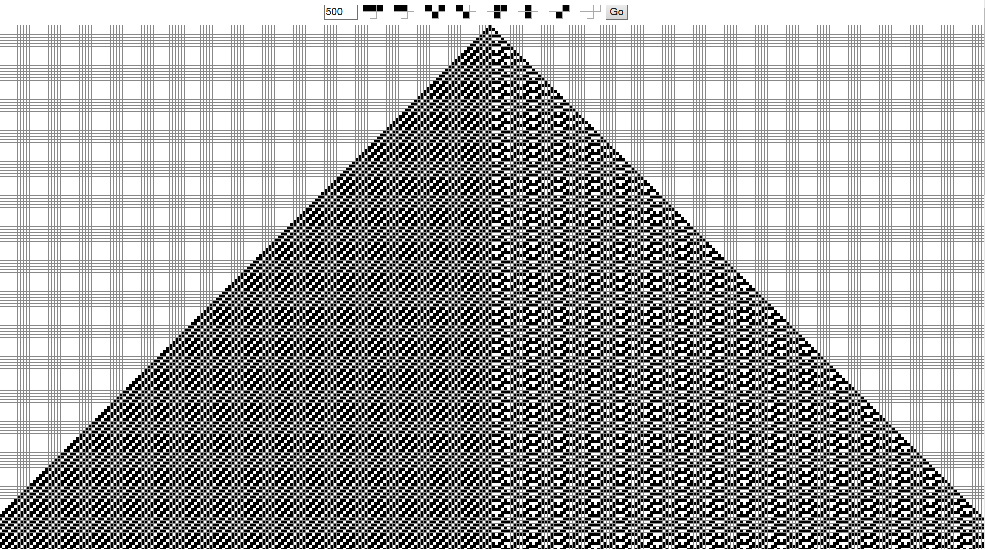

We will admit this is not our most aesthetic lab write-up; however, all documentation is listed on the associated pages.

Problem 1 (Note All limit cycles are drawn out and attached to the end).

A)

Rule 30

See Pages (1-6)

Rule 62

L = 4 L = 5 L = 6 (Pages 7,8,9,10,and 16)

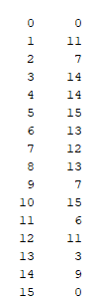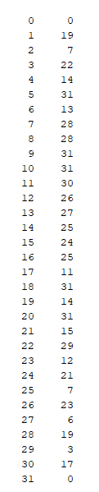

Rule 110 (See Pages 11, 12, 13)

L = 4 L = 5 L = 6 (see appendix)

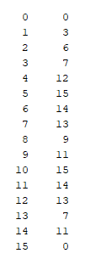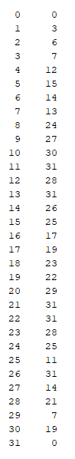

1. The cycles above do appear to be sensitive to changes in L for the average length of their limit cycles. For rule 62, it appears to be less sensitive as the average tends to be around 3, however rule 110 is sensitive, at L = 4 and 5, being between 1-2, while at L = 6 being between 6-7. For rule 30, the average limit cycle length drops from 3 to 2.5 to 1 at L = 6, showing that it is sensitive to changes in L.

b) For Rule 110 L = 4, the perturbations of initial conditions 1,3, 7,15 are negligible because 15 is the only one that leads to a different attractive cycle. Therefore, the rule is ¼ in sensitivity. For L = 5, there is no change from the perturbations of the initial conditions in determining which limit cycle the initial condition ends. For L = 6, 1, 3, and 7 all end in the same limit cycle; however, 15 ends in a different cycle. Therefore, this has a sensitivity of ¼ as it could change the resulting end behavior of ¼ of the perturbations to the initial conditions.

See Page 14 for Automata

Problem 2:

Below are screenshots of the output for Rule 30 when L is large. Each one has small perturbation of the initial conditions that greatly affects the output.

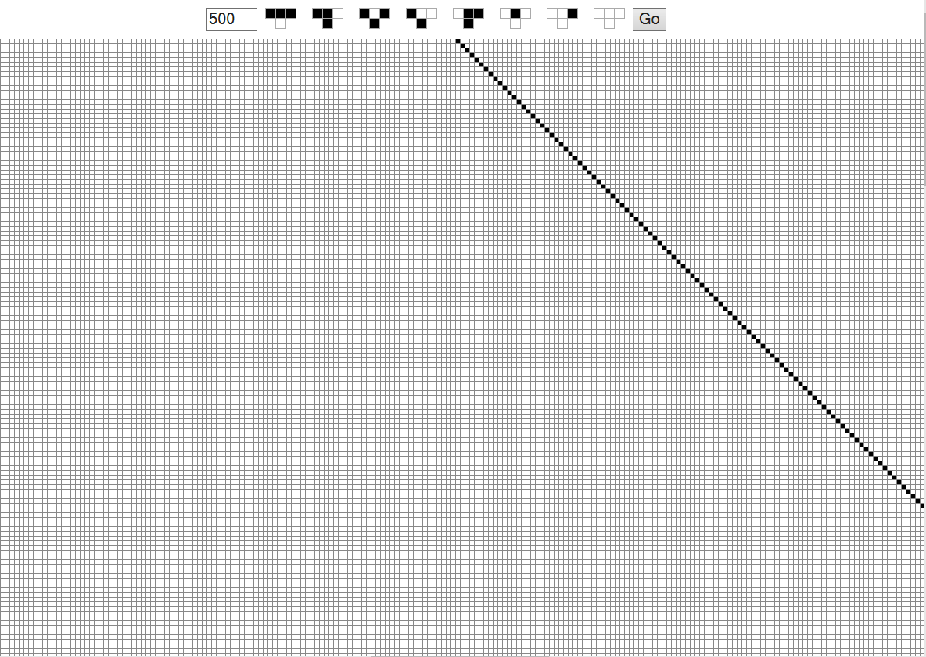

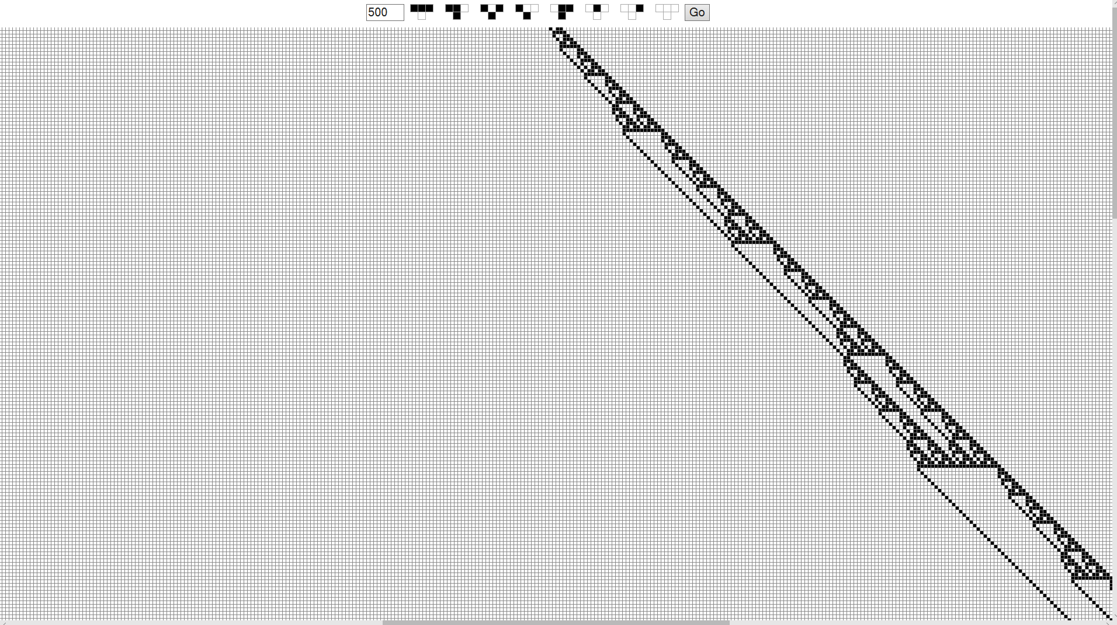

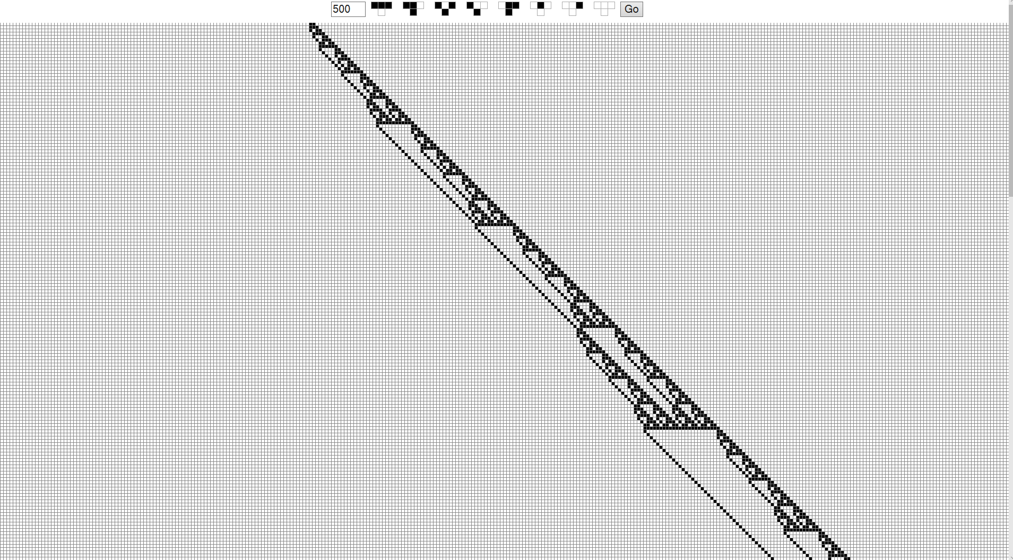

The next three screenshots correspond to Rule 62. There also were small perturbations to the initial conditions but there was minimal effect on the end behavior.

Rule 110 is also shown below. Small perturbations were made to the initial conditions and they had a minimal impact to the system.

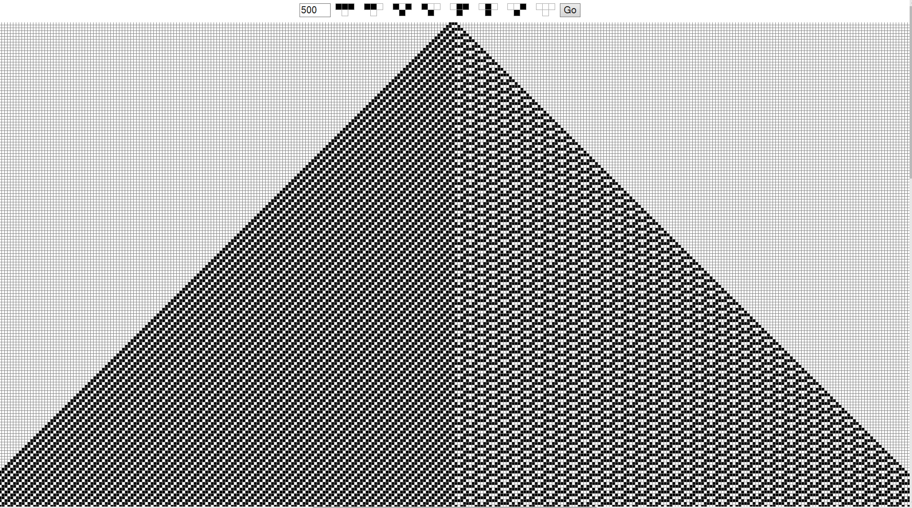

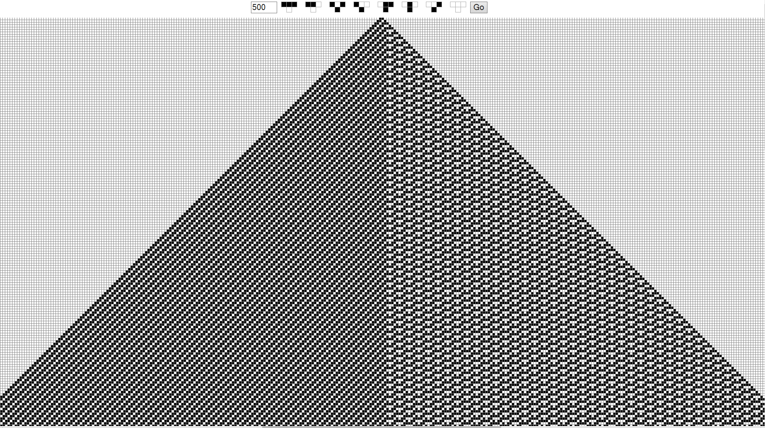



The Next rule was 110, and its initial conditions also had a minimal effect on the end behavior when L is large.

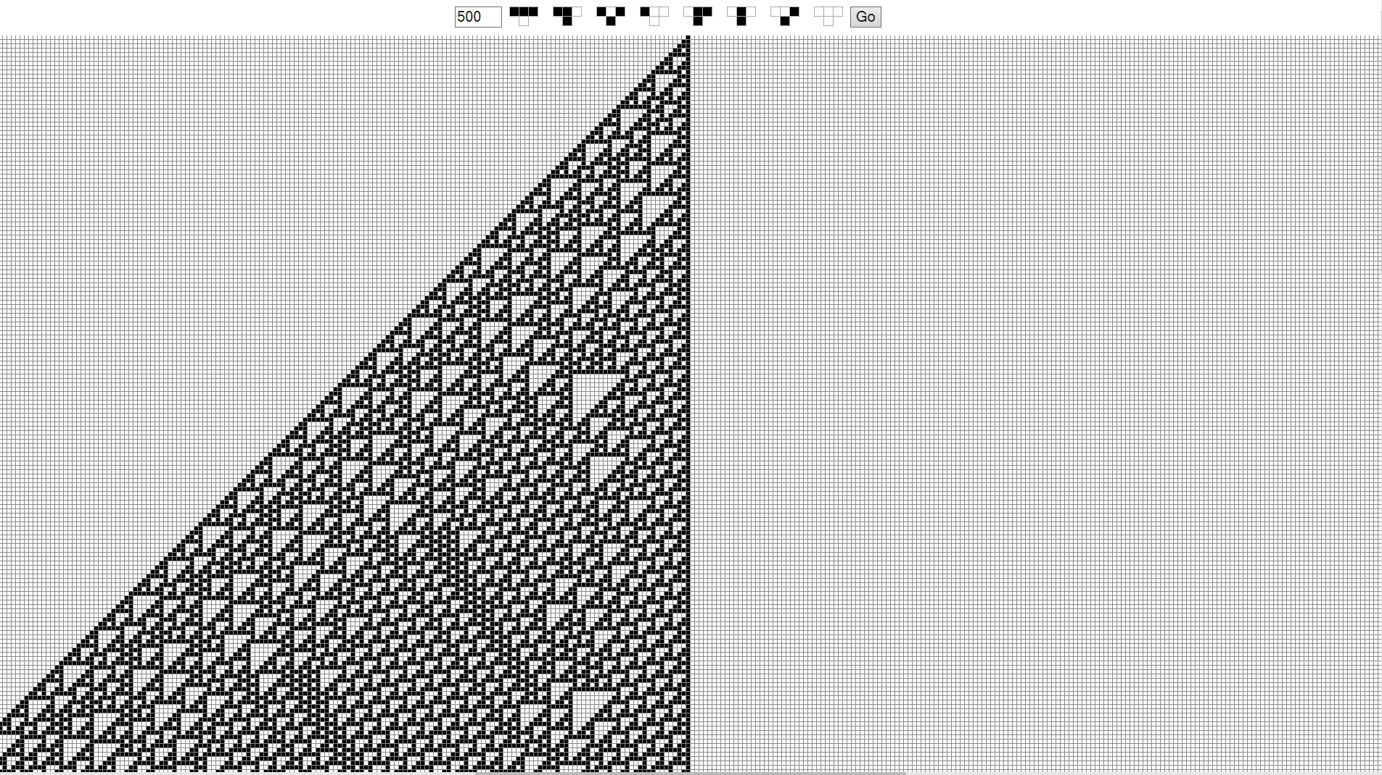

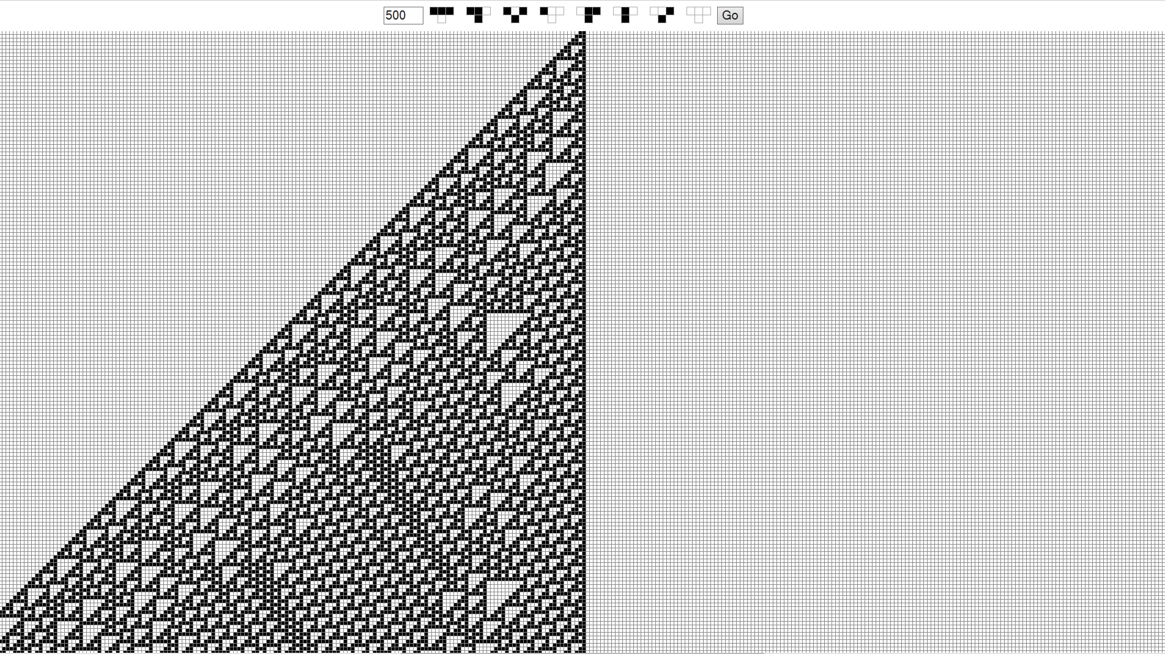

When L is large it appears that initial conditions do not play a significant role in the evolution of the system. In part a, they played a larger role because L was significantly smaller. 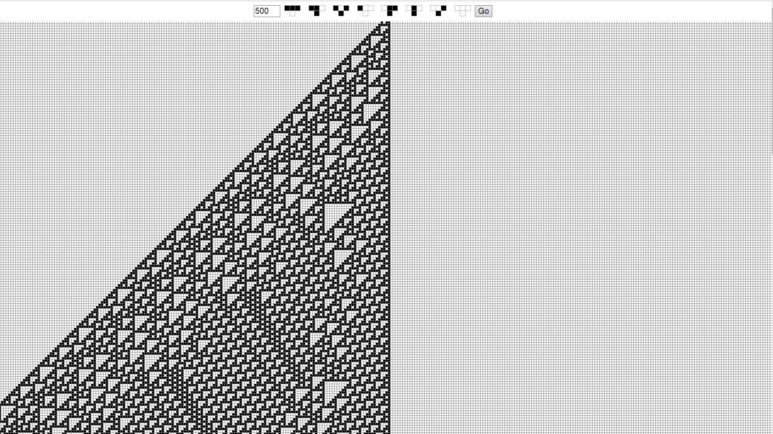

Problem 3a (Page 15)

Problem 3b (Pages 17, 18)

Problem 4a (Pages 19, 20)

Problem 4b (Pages 21, 22)